**NÓMINA DE ESTUDIANTES**

**PRIMERO DE BÁSICA**

**AÑO LECTIVO 2021-2022**

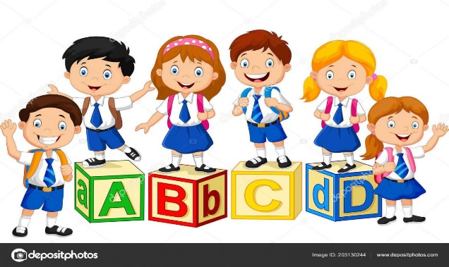

|  |  |
| --- | --- |
|  | **NOMBRES COMPLETOS** |
| 1 | ANGAMARCA DOMINGUES CRISTINA ELIZABETH |
| 2 | BUSTOS STOPPER BENJAMIN NICOLAS |
| 3 | CAMPOVERDE PEREZ MILEY SCARLETH |
| 4 | CHALCO ZHAGUI ROSA GUADALUPE |
| 5 | CHUU KUNAMP YUCENCA YAJANUA |
| 6 | CORDERO TENE ERIK MATHEW |
| 7 | DOUGLAS SOTOMAYOR ANDY SEBASTIAN |
| 8 | GARCIA BARRERA BRENDA ARIANA |
| 9 | GONZALEZ MENDEZ ANTHONY SANTIAGO |
| 10 | GOROTIZA MARCA SOFIA DEL CISNE |
| 11 | GUARTAZACA MARTINEZ ALAN DANIEL |
| 12 | JEREZ CATUTO SOPHIE VALENTINA |
| 13 | MALDONADO AGUILAR ISABELLA AYLIN |
| 14 | MASHIANT KAIKIAT ISRAEL SEBASTIAN |
| 15 | ONCE NEIRA ALAN MAXIMILIANO |
| 16 | ONCE NEIRA CHRISTIAN AZAEL |
| 17 | PEÑALOZA GARCIA SAID EMILIO |
| 18 | PILLAGA VILLAVICENCIO JORGE JULIAN |
| 19 | RODRIGUEZ VALLES ALEXIS ABRAHAM |
| 20 | ROMERO TIGRE ALEX EDUARDO |
| 21 | SAGBAY HERAS BRIGGIT ESTEFANIA |
| 22 | SANCHEZ FAJARDO IAN JESUS |
| 23 | SANTANA MORALES SASHA ANGELINA |
| 24 | SINCHI JADAN IVAN ESTEBAN |
| 25 | SOLORZANO RIVERA MARIA JOSE |
| 26 | TAPAICELA ROMERO JUAN CARLOS |
| 27 | TIGRE ORTIZ KIMBERLY ANAHI |
| 28 | TORRES CARDENAS OSWALD SANTIAGO |
| 29 | VILLA CAJAMARCA CHRISTIAN EZEQUIEL |
| 30 | ZURITA MELENDRES JEFFERSON ALEXANDER |